SIMATS ENGINEERING
ASSESSMENT TOOL 2
NAME : MONISHVARAN V
REG NO: 192424398
COURSE NAME: Database Management Systems
COURSE CODE: CSA0501

COURSE OUTCOME COVERED
CO1: Analyze DBMS architecture, different data models, schema types, and design ER/EER diagrams, relational schemas for case-based scenarios by identifying entities and relationships. (BL1, BL2)

Activity Tool : Concept Mapping (Medium)
Assessment Tool Weightage: 35%
Dr
QUESTIONS Total Marks: 50
Q.No | Question | Bloom's Level | Marks
1 | Construct a concept map linking the following terms: DBMS, Schema, Instance, Data Model, ER Diagram, Entity, Attribute, Relationship. | BL2 – Understand | 5
2 | Create a concept map for the three-level ANSI/SPARC architecture showing data independence at each level. | BL2 – Understand | 5
3 | Map the relationship between file-based systems and database systems, highlighting the problems solved by DBMS. | BL2 – Understand | 5
4 | Design a concept map for ER diagram components: entity, weak entity, attribute types, relationship types, and participation constraints. | BL2 – Understand | 5
5 | Construct a concept map comparing Hierarchical, Network, and Relational data models with their key properties. | BL2 – Understand | 5
6 | Develop a concept map for the EER model showing how it extends the basic ER model with generalization, specialization, and aggregation. | BL2 – Understand | 5
7 | Create a visual concept map for the DBMS software architecture, illustrating the flow from user request to data retrieval. | BL2 – Understand | 5
8 | Map the data models discussed in CO1 to real-world applications and explain the suitability of each model. | BL2 – Understand | 5
9 | Construct a concept map for schemas and instances, showing how they relate to physical and logical data independence. | BL2 – Understand | 5
10 | Design a concept map for the roles and responsibilities in a DBMS environment: DBA, End User, Application Developer. | BL1 – Remember | 5

Code of Conduct:

I MONISHVARAN V (192424398) (Name / Reg No) certify that this submission is my original work and that I have adhered to the guidelines specified for this assessment.
I understand that any violation of academic integrity rules will result in disciplinary action.

Signature of the student:


RUBRICS FOR CALCULATION:
Criteria | Weightage | Level 4 (Exemplary) | Level 3 (Proficient) | Level 2 (Developing) | Level 1 (Beginning)
Concept Identification | 25% | Identifies all key concepts from literature accurately and comprehensively | Identifies most key concepts with minor omissions | Identifies limited concepts; some are irrelevant or missing | Fails to identify essential concepts
Linkages | 25% | Establishes clear, meaningful, and accurate relationships between concepts | Shows correct relationships with minor gaps | Relationships are weak, unclear, or partially incorrect | No meaningful relationships established
Organization | 20% | Concepts are well-structured hierarchically with logical flow and grouping | Mostly organized with minor structural issues | Some organization but lacks clear hierarchy | No logical organization or structure
Integration of Literature | 20% | Integrates multiple studies effectively to show connections and comparisons | Shows some integration of literature | Limited integration; mostly isolated concepts | No integration of literature evidence
Clarity | 10% | Concept map is clear, neat, visually structured, and easy to interpret | Generally clear with minor readability issues | Clarity is reduced; difficult to interpret in parts | Poorly presented and hard to understand

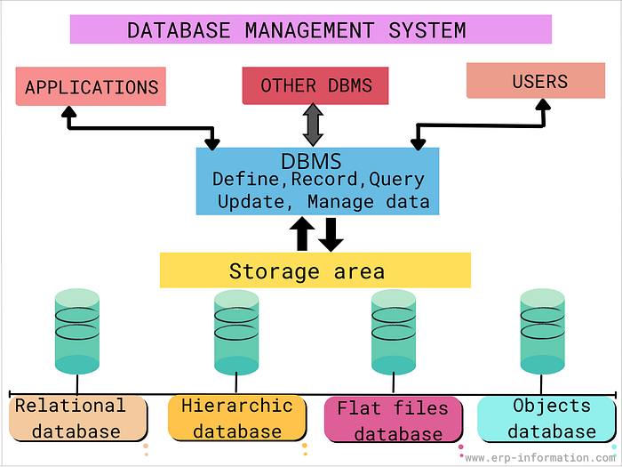

- Concept Map: DBMS, Schema, Instance, Data Model, ER Diagram, Entity, Attribute, Relationship
- DBMS → manages → Schema (blueprint of database)
- Schema → defines → Data Model (structure)
- Instance → actual data → conforms to Schema
- Data Model → represented by → ER Diagram
- ER Diagram → consists of → Entity, Attribute, Relationship
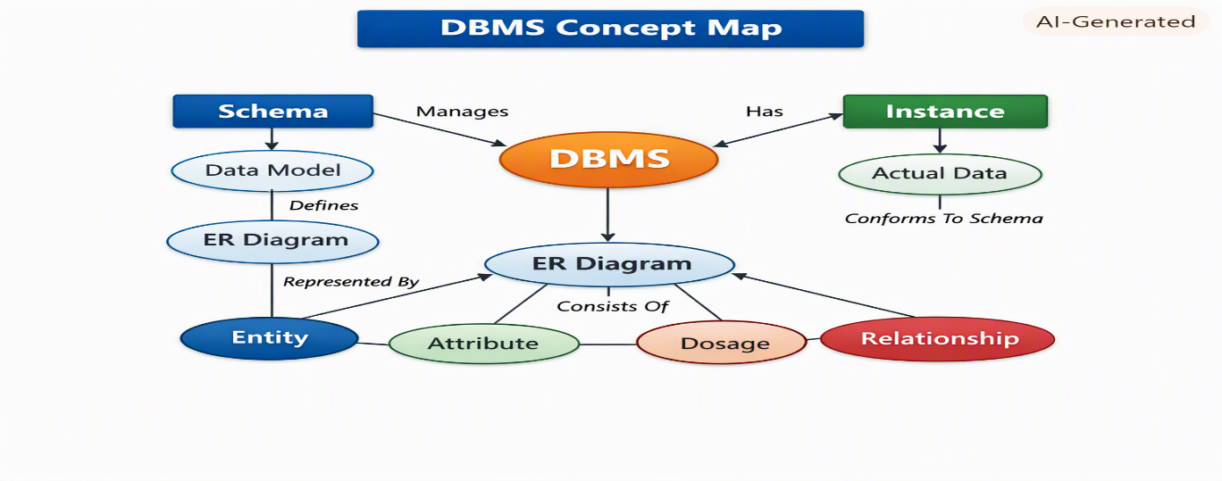
2️⃣ Concept Map: ANSI/SPARC Three-Level Architecture
- External Level (View Schema) → user-specific views
- Conceptual Level (Logical Schema) → overall logical design
- Internal Level (Physical Schema) → storage details
- Data Independence:
  - Logical Independence → change logical schema without affecting views
  - Physical Independence → change physical storage without affecting logical schema
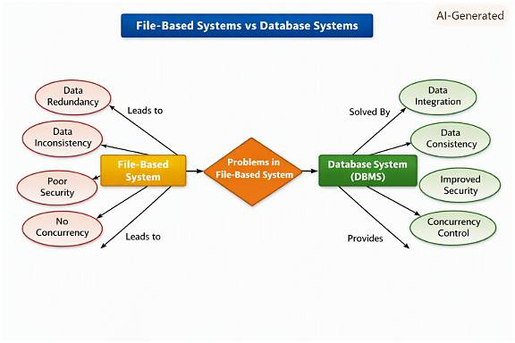

3️⃣ Concept Map: File-Based vs Database Systems
- File-Based System → problems: redundancy, inconsistency, poor security, no concurrency
- DBMS → solves: central control, reduced redundancy, integrity constraints, security, concurrency control
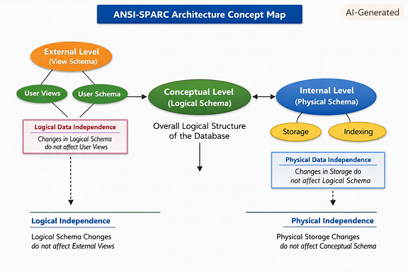
4️⃣ Concept Map: ER Diagram Components
- Entity → strong entity
- Weak Entity → depends on strong entity
- Attributes → simple, composite, derived, multivalued
- Relationships → one-to-one, one-to-many, many-to-many
- Participation Constraints → total vs partial participation
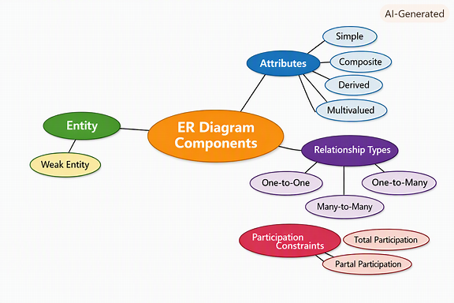
5️⃣ Concept Map: Data Models
- Hierarchical Model → tree structure, parent-child
- Network Model → graph structure, many-to-many links
- Relational Model → tables, rows, columns, keys
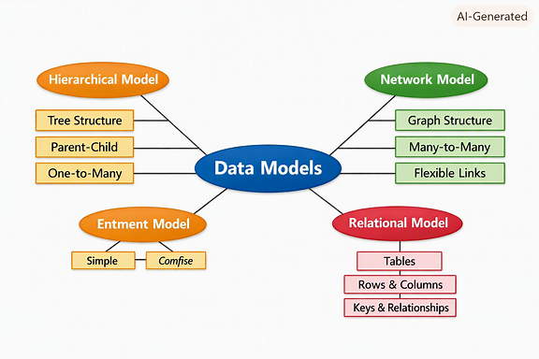
6️⃣ Concept Map: Extended ER (EER) Model
- EER extends ER with:
  - Generalization → combine entities into superclass
  - Specialization → divide entity into subclasses
  - Aggregation → treat relationship as entity
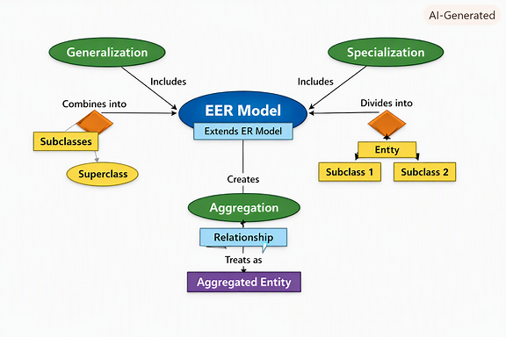
7️⃣ Concept Map: DBMS Software Architecture
- User Request → Query Processor → Execution Engine → Storage Manager → Database → Data Retrieval → User
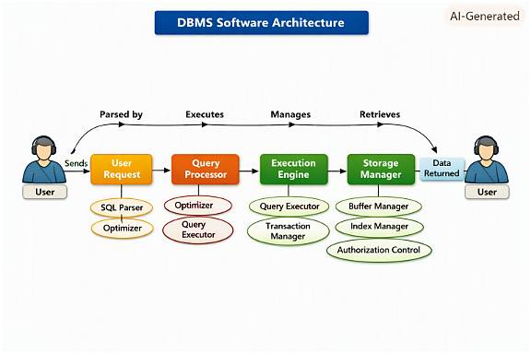

8️⃣ Data Models and Applications ER Diagram
Entities:
- Data Model (Model_ID, Name, Structure_Type)
- Application (App_ID, Name, Domain)
Relationships:
- Used_For → connects Data Model ↔ Application
Example Connections:
- Hierarchical → XML Storage
- Network → Telecom Systems
- Relational → Banking, ERP
9️⃣ Schemas and Instances ER Diagram
Entities:
- Schema (Schema_ID, Type, Description)
- Instance (Instance_ID, Timestamp, Data_State)
- Data Independence (Independence_ID, Type: Logical/Physical)
Relationships:
- Defines → Schema ↔ Instance
- Ensures → Schema ↔ Data Independence
🔟 DBMS Roles and Responsibilities ER Diagram
Entities:
- DBA (DBA_ID, Name, Role, Responsibility)
- End_User (User_ID, Name, Access_Level)
- Application_Developer (Dev_ID, Name, Project)
- Database (DB_ID, Name, Type)
Relationships:
- Manages → DBA ↔ Database
- Uses → End_User ↔ Database
- Develops → Application_Developer ↔ Database
- Supports → DBA ↔ Application_Developer

